Contents

8. Horizontal enablers 1
8.1 Education and skills for the green transition 1
8.1.1 The energy sector as a catalyst for the green transition 1
8.1.2 Learning for the green transition 3
8.2 Better coordination: Governance for transformative change 5
8.2.1 Megatrends in the green transition 5
8.2.2 Orchestrating the implementation of the green transition 7
8.2.3 The path forward 8
8.3 The potential of behavioural insights for policy making 11
8.3.1 Participation and citizen engagement 13
8.4 Cities and regions in the green transition 16
References 2

- Horizontal enablers
  - Education and skills for the green transition
This section explores the enablers and challenges of equipping Europe’s workforce for the green transition. By connecting skills development with the broader goals of a clean, just, and competitive transition, it highlights how education and training systems can adapt to meet evolving labour market needs, ensuring the effective implementation of the green transition and strengthening Europe’s socio-economic resilience.
Achieving the goals of the European Green Deal and of the Clean Industrial Deal [1] requires a profound transformation of Europe’s economy and workforce, underpinned by a fair, inclusive, and competitive transition. This shift spans all dimensions of the green transition, requiring the development of green skills and the creation of jobs aligned with sustainability objectives. The workforce must be equipped with the knowledge, competencies, and adaptability needed to support this systemic change, from primary sectors to emerging industries. To increase competitiveness, the EU will focus on adult and lifelong learning, and up- and re-skilling, to ensure a good alignment with labour market demands. The transition to sustainability offers unparalleled opportunities to simultaneously address socio-economic and environmental challenges. Green skills encompass both technical abilities and cross-sectoral competencies, such as systems thinking and collaboration, which enable the workforce to meet the demands of rapidly evolving markets. As highlighted by recent assessments (European Commission, 2023), this transformation is expected to generate millions of jobs across all sectors of the green economy, particularly in roles requiring mid-level and high-level skills. Promoting skills and quality jobs while ensuring social fairness is one of the horizontal enablers of the EU Competitiveness Compass [2], a reminder that the green transition has to be fair and competitive for our economy and society.
The success of this transition hinges on addressing structural gaps in education and training. Existing EU frameworks, such as GreenComp, provide a shared reference for integrating sustainability competences [3], while financial instruments such as the European Social Fund+, Youth Guarantee, and Erasmus+, support re-skilling and up-skilling.
Additionally, investments including the EUR 3 billion for sustainable school infrastructure demonstrate the EU’s commitment to preparing future generations for the green economy. This commitment is reinforced by the Clean Industrial Deal, which prioritizes access to industry-needed skills and worker support during the transition. As part of this effort, the Commission will establish a Union of Skills, investing up to € 90 million from Erasmus+ in workforce training and quality job creation in strategic industries. The Union of Skills will include a STEM Education Strategic Plan, a Basic Skills Action Plan focused on school education, and a European Strategy for Vocational Education and Training while strengthening the European Universities Alliances. Additionally, mobility across the EU will improve with better recognition of skills and training, extending to skilled professionals from third countries.
    - The energy sector as a catalyst for the green transition
The transition from brown to green jobs in the EU, driven by the European Green Deal, is expected to bring significant changes in the Member States’ labour markets. The energy transition, and related scale-up of EU net-zero technology manufacturing, will accelerate demand for workers with green skills. Skilled technical workers, already in persistent shortage, are in the high demand and labour shortages may hinder the energy transition, if not addressed [4].
Jobs in clean energy technologies are growing faster than in the rest of the economy [5]. This sector employs more than 2 million people in the EU. Most of these jobs are in the renewable energy sector [6] (mainly heat pump, solar and wind) and the manufacturing segment. However, this sector is marked by a high job vacancy rate, with 15% of companies in the area of manufacturing electric equipment reporting labour shortages as the main factor limiting their production.
As the energy transition unfolds, structural mismatches [5] can lead to persistent shortages in some of the technical skills and occupations, such as installers and repairers of electrical equipment and machinery mechanics [7]. The energy industry faces the double challenge of an aging workforce and the changing skills needs resulting from digitalisation [8]. In addition, the electricity sector is among the most affected by the demographic shift, due to the ageing population [7] and the persistent underrepresentation of women. Gender disparities in scientific publications, particularly in STEM fields, also persist [9]. Demand for trained and skilled technicians will remain high, since 75% of the jobs created by the energy transition will be in these roles [10].
The European Commission [11] has recently concluded that most Member States have not set specific objectives or allocated funding to address the skills gaps necessary for implementing the Net-Zero Industry Act (NZIA) [12]. Increasing the production of clean technologies will require further investment in skills, estimated to range from EUR 1.7 billion to EUR 4 billion [13].
The raised climate ambition and accelerated deployment envisaged in the REPowerEU Plan could create up to 1 million additional jobs by 2030 [14]. Some of the technical profiles needed are transferrable from the fossil fuel industry and other related sectors. The development of job-specific training programmes, including EU-wide certification and mutual recognition of skills, is crucial to facilitating sufficient labour supply. Nevertheless, the shortage in high-skilled occupations may create a bigger bottleneck as it takes longer to obtain the required educational credentials [7]. The clean energy and green economic transition are taking place parallel to and in the context of digitalisation. These simultaneously occurring global trends require education and skills responses from policy makers, companies and education institutions alike [8].
As employment in high-pollution sectors declines and low-pollution sectors grow, economic disparities and poverty risks may rise, particularly for workers in fading industries. However, Member States' tax-benefit systems can help mitigate these effects by supporting those most affected by the transition, redistributing income, and offering social protection. These systems play a crucial role in ensuring the green job transition results in a more equitable distribution of economic outcomes across the EU, protecting vulnerable populations from the worst impacts (see chapter 7 on fair transition). The clean energy sector has the potential to bring back some of the industrial jobs that have been disappearing from Europe. Importantly, these jobs have an opportunity to fill the void in medium-skilled jobs as nearly 60% of job creation could fall into this category [15]. Renewing societal trust in a labour market that creates life-long opportunities and security can turn the labour force from a bottleneck to a positive force in the transition to climate neutrality.
    - Learning for the green transition
The Eurydice assessment provides insights into how education systems in the Member States can effectively support the green transition implementation [16]. While sustainability features prominently in all Member States' curricula, the assessment identifies areas where targeted improvement could accelerate progress. Teacher preparation, for instance, emerges as a key area of focus, with many educators expressing strong interest in sustainability topics but seeking additional support to teach them effectively.
Investing in professional development for sustainability education presents a significant opportunity for system-wide improvements. EU-level collaboration on certification standards could facilitate consistency in quality while supporting professional mobility across Member States [16]. Additionally, aligning education outcomes with evolving labour market needs, particularly in technical fields, could help expand the workforce, especially in light of demographic shifts and gender imbalances.
The green transition has profound economic implications for the labour market. Recent analysis shows that nearly 60% of new jobs in the clean energy sector will require medium-level skills [15], highlighting the need for a strategic approach to technical and vocational training. Ensuring the effective implementation of these programs will support workforce transitions while maintaining high quality standards. Additionally, the development of common certification approaches will strengthen workforce mobility across Member States while ensuring consistent quality standards.
The ‘New Skills Agenda’ was introduced to foster sustainable competitiveness, social fairness, and resilience. The agenda set ambitious objectives for upskilling and reskilling workers to navigate the green transition. It also includes training for circular economy activities, such as design, materials sourcing, maintenance, repair, refurbishment, repurposing, and recycling. For example, new benchmarks under the Critical Raw Materials Act have created a demand for skills related to circularity and sustainability across various value chains. At the same time, there is a general lack of technical expertise, both in the public and private sectors, to develop and implement innovative circular solutions.
Investing in the development of skills within other areas such as the food chain workforce is equally critical. Fostering a skilled and adaptable workforce, along with promoting research and innovation in areas like sustainable agriculture and food technology, will be key to long-term success. These efforts will drive increased efficiency and productivity, benefiting all stakeholders.
On the education side, bridging the knowledge gap between consumers and the resources used to produce their food is essential. By fostering transparency and educating consumers on sustainable practices, informed choices can be made that support the overall health of the food system. By implementing these measures, the EU can create a food supply chain that is both economically viable and environmentally responsible, ensuring a secure and sustainable food future for all. For this purpose and spanning food as well as other households’ consumption products (including housing, mobility, appliances, and household goods), the JRC has developed the Consumer Footprint Calculator, an online tool to raise EU citizens awareness about their personal consumption footprint [17].

Box xx. Consumer Footprint Calculator
The Consumer Footprint Calculator is a tool for the quantification of the environmental impacts of the consumers’ choices in terms of food, housing, mobility, appliances and housing goods. It is an adapted version of the Consumption Footprint model (see Chapter 3) and is available online in the 24 official languages of the EU, to support citizens calculating the environmental impacts of their consumption patterns and assess how changes in their lifestyle may affect their personal footprint [17].
Compared with other online tools, the Consumer Footprint Calculator not only calculates the CO2 production for the consumers but it assesses the impacts through 16 environmental impact categories of the Environmental Footprint method). The consumer footprint of each individual is calculated in absolute sustainability terms and also in comparison with the planetary boundaries and the Sustainable Development Goals, providing the user links to sustainability ”good practices”, to increase awareness and encourage more sustainable lifestyles.
Figure 4. Overview of the Consumer Footprint Calculator
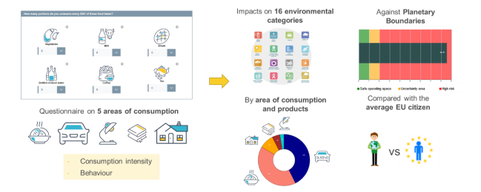
Source: JRC, [17].

Similarly, it is vital to ensure that land ecosystem restoration is properly resourced with skilled professionals who can address the socio-ecological complexities of restoration projects. These professionals must be equipped with the knowledge, tools, and expertise to implement science-based restoration techniques, as well as monitor and evaluate progress effectively [19].
Increasing green education and re-skilling requires the appropriate financial support: at this purpose, the EU has established key frameworks and financial instruments to integrate sustainability competences into education and training systems. Besides the GreenComp framework already mentioned previously, the Education for Climate Coalition facilitates practical implementation, while the enhanced Erasmus+ Programme (2021-2027) supports targeted actions through dedicated funding, including the 3 billion EUR for sustainable school infrastructure mobilised by the EU through the European Investment Bank and structural funds.
To maximise the impact of these frameworks and instruments, strategic coordination is essential. Effective deployment of EU funding mechanisms, combined with systemic changes in educational institutions—from infrastructure improvements to curriculum development—can significantly amplify the impact of these investments. Member States that have successfully integrated sustainable education practices into their teaching, infrastructure, and assessment systems provide valuable evidence that this coordinated approach accelerates the development of green skills and competences.
The ongoing implementation of the EGD will benefit from continued attention to educational strategies. While robust frameworks exist through various EU initiatives, enhanced coordination could further support the evolving needs of the green economy. Aligning educational outcomes with green economy requirements strengthens both the implementation of the EGD and the goals of a just transition. By building the long-term capacity of the education sector, the EU can ensure that the transition to a sustainable future creates opportunities that are accessible across all regions [5].

  - Better coordination: Governance for transformative change
    - Megatrends in the green transition
The success of the green transition is impacted by overarching global megatrends, long-term driving forces that will have significant influence on the future of the EU and globally. To mention a few, climate change and environmental degradation, aggravating resource scarcity, continuing urbanization, accelerating technological change, growing consumption, widening inequalities, increasing demographic imbalances, and geopolitical shifts, these megatrends affect the different components of the green and digital transitions. They are highly interconnected, and successful outcomes require a nuanced understanding of how these megatrends influence each area. To anticipate and prepare for those changes and support the transitions to a green, digital and fairer future, strategic foresight is crucial to build an effective evidence-based anticipatory policy-making. Strategic intervention areas—ranging from governance reform to economic and educational shifts—play a crucial role in guiding the EU’s approach to navigating these challenges.
The following synthesis highlights how strategic interventions across the green transition thematic areas support transformative change:
- Climate ambition: Policies to drive decarbonisation address both local and global megatrends of climate change. Addressing climate megatrends requires coordinated interventions across energy and industrial sectors to ensure a comprehensive approach to emissions reduction. Through coherent policy mixes, this area emphasizes regulatory alignment and economic incentives to drive decarbonisation.
- Clean, affordable, and secure energy: Here, adaptability is key. Policies prioritize flexible, resilient energy systems that respond to fluctuations in demand and supply. This approach supports the EU’s goal of energy independence while ensuring affordability, especially in the context of rising resource scarcity.
- Circular economy: interventions in this area foster innovation in green technologies and encourage sustainable consumption. They aim at realigning global trade and resource use, which is particularly crucial in reducing Europe’s dependence on high-emission industries. This area focuses on reshaping production-consumption patterns through targeted policies that foster sustainable economic models. Innovations in green technologies and circular practices are facilitating a transition towards low-waste, high-efficiency systems.
- Sustainable and smart mobility: Urbanisation pressures drive interventions in this area, focusing on adaptive frameworks for sustainable transportation. Policy mixes emphasize green infrastructure and incentives for low-emission vehicles, helping to manage urban expansion and reduce pollution.
- Greening the Common Agricultural Policy: To address food security and resource management, this area aims at place-based interventions that encourage sustainable agricultural practices. Orchestrated stakeholder collaboration is central, ensuring that local initiatives align with broader sustainability goals.
- Preserving and protecting biodiversity: Resource scarcity and shifting geopolitical influences drive policies in these areas, where multi-level governance structures are needed. This includes interventions for ecological conservation that prioritize adaptive, place-based strategies to address uncertainties tied to climate and biodiversity loss. The EU emphasizes collaborative frameworks to manage biodiversity, responding dynamically to environmental changes while maintaining ecosystem health.
- Zero Pollution Ambition: Tackling pollution demands robust regulatory frameworks. This area benefits from cross-sector policy coherence that aligns environmental, industrial, and public health policies to achieve broad anti-pollution outcomes.

To meet the EU transformative sustainability goals, gaps in governance coherence, adaptive policy frameworks, and multi-actor collaboration need addressing. Opportunities exist in developing a flexible governance structure that can adjust to the evolving impacts of megatrends while fostering an inclusive, collaborative approach across sectors and levels of government. By emphasizing integrated policy mixes, adaptive capacity, and collaborative orchestration, the EU can effectively harness agency to drive sustainable transitions across all thematic areas, setting a global standard for sustainable development.
The transformation required by the European Green Deal demands sophisticated governance models that effectively combine policy mixes with enhanced agency for sustainability transitions [20], [21]. Success depends not only on developing collaborative capabilities but also on strategically deploying policy mixes that can address multiple megatrends simultaneously while enabling transformative change [20].
Three key aspects of agency emerge as critical for success. First, the ability to shape through policy mixes must integrate regulations, incentives, and cross-sectoral policies effectively. Second, navigating uncertainty requires developing adaptive governance frameworks that can respond to rapidly changing conditions. Third, orchestrating processes and relationships becomes essential for enabling collective action and stakeholder alignment [20].
The analysis reveals that while governance challenges are substantial, they can be addressed through strategic interventions that combine policy coherence, adaptive frameworks, and collaborative approaches [20], [22]. Success will increasingly depend on:
- Developing integrated policy mixes that can address multiple sustainability challenges simultaneously
- Building adaptive capacity across governance levels to respond to emerging challenges
- Strengthening multi-stakeholder platforms for collective action
- Creating learning systems that enable continuous improvement and innovation [21], [23].
The future of European sustainability transitions relies not just on technological innovation but on our capacity to innovate in governance and policy deployment while fostering agency among all actors involved in the transition process [20], [22].

    - Orchestrating the implementation of the green transition
The European Green Deal represents an unprecedented socio-economic transformation strategy that demands coordinated action across multiple governance levels [20]. The EU is often regarded as a paradigm of multilevel governance, further solidified with the enactment of its first Climate Law in 2021. In fact, it demands the EC to enable an inclusive process, involving all societal actors, to facilitate the achievement of the climate ambitions, considering Local and Regional Authorities (LRAs) as often best positioned to implement tailored climate solutions reflecting community needs.
Current governance structures, while evolving, face significant challenges in enabling the systemic changes needed for sustainability transitions. The implementation of the EGD reveals several persistent implementation challenges in current governance structures [22]. A fundamental misalignment exists between EU-level ambitions and local/regional implementation capacity, often resulting in fragmented decision-making and limited coordination between national and local authorities [21]. This is compounded by insufficient cross-sector collaboration mechanisms and resource constraints at regional and local levels, which hamper effective implementation. Multi-level governance adds an additional layer of complexity, as local, national, and international actors must coordinate efforts and ambitions to deliver changes [24]. The EGD ambitions demand both coherent policy frameworks and effective national implementation first. Yet, differences in national approaches, administrative limitations, and varying levels of commitment to EU goals slow progress and complicate the path to achieving sustainability targets across the region. At EU level, the complexity of the EU administration can hinder the reforms and innovations, or their speed, needed to achieve climate neutrality in 2050 [25], [26].
The highlighted challenges are being met with emerging opportunities for transformation [23]. Networks for knowledge sharing between cities and regions are growing, while new participatory and co-creation approaches are gaining traction [27]. The rising importance of regional and city-level initiatives, coupled with innovative public-private partnership models, presents new pathways for implementation [20], [23]. A successful example of this can be found in the innovative mission-oriented approach, with specific reference to the 100 Climate Neutral and Smart Cities programme, which establishes direct contact between the EC and citizens and support cities to orchestrate the designing of Climate City Contract under the NetZero cities initiative. Similar approaches in other missions and New European Bauhaus initiative have also already delivered impact.
The development of agency in sustainability transitions requires attention to three interconnected approaches [21].
- Shaping through Policy Mixes that integrate regulations, incentives, and cross-sectoral policies while aligning objectives between governance levels [23]. This approach creates synergies between initiatives and supports experimentation and learning. For example, the EU’s Climate Ambition is advanced by regulatory frameworks that incentivize carbon reduction and clean technology investments. These policy mixes provide cohesion across levels of governance, allowing for targeted efforts to phase out unsustainable practices, particularly in high-emission sectors. The “Fit for 55” package uses an integrated approach, combining carbon pricing, renewable energy mandates, and support for green technology. This helps actors navigate the climate megatrend by promoting a unified, EU-wide approach to emissions reduction.
- Navigating Uncertainty. Adapting to uncertainty is essential for the EU to respond dynamically to shifting economic and environmental factors. It requires developing adaptive management approaches and building flexibility into governance arrangements, enabling continuous learning and adjustment through risk-sharing mechanisms [20], [21]. Strategic interventions foster resilience by building flexibility into policies and encouraging adaptive governance. This is especially relevant for sectors like energy and mobility, where rapid technological changes and fluctuating resource availability necessitate adaptive frameworks. The strategic use of scenario planning in the EU Sustainable and Smart Mobility Strategy allows it to account for varied future developments, such as shifts in fuel types or transportation demand, which are crucial in a context of rapid urbanization and resource challenges.
- Orchestrating Processes and Relationships. Orchestrating collaboration across sectors and levels of government fosters an environment for collective action. It involves building trust and legitimacy while creating shared visions and goals, establishing clear roles and responsibilities, and developing effective coordination mechanisms [23]. By strengthening multi-stakeholder platforms, the EU enables alignment across actors, enhancing the effectiveness of sustainability transitions. This approach is evident in Greening the Common Agricultural Policy, where relationships between local governments, farmers, and environmental bodies are coordinated to create synergies that support sustainable agriculture practices. The EU Biodiversity Strategy leverages local and international partnerships to orchestrate conservation efforts across ecosystems, showing how cross-actor collaboration can amplify impact and address global biodiversity concerns.

    - The path forward
Implementation across key policy areas reveals distinct governance challenges and opportunities that require tailored yet integrated approaches [22]. Each area demonstrates unique governance needs while sharing common threads of multi-level coordination and stakeholder engagement. The successful implementation of the European Green Deal requires integrating the three interconnected approaches to agency across different thematic areas [21]. Policy mixes, uncertainty navigation, and process orchestration must work in concert to enable transformative change.
Climate action implementation demands stronger vertical integration between EU, national, and local levels. Member States often differ in their commitment to climate targets, with some relying only on binding EU policies, while others establish national climate laws. This variability, coupled with inadequate support for monitoring and evaluation at the municipal and sub-national levels, impedes the efficient tracking of progress toward the EGD’s climate goals [28]. Local authorities often struggle with limited resources and technical and anticipatory capacity to implement ambitious climate targets [22]. However, emerging city networks and regional partnerships are creating new opportunities for knowledge sharing and collective action. The success of climate initiatives increasingly depends on the ability to mobilize local stakeholders while ensuring policy coherence across governance levels [20]. Cities have emerged as particularly important actors, with their capacity to integrate climate considerations into urban planning, building regulations, and local transport policies, and have shown abilities to set highly ambitious mitigation targets [20].
Policy mixes need to combine emissions reduction targets with adaptation measures, while building flexibility to navigate uncertain climate impacts. Process orchestration becomes crucial in engaging stakeholders across sectors and governance levels to implement these policies effectively [22]. Dialogue and cooperation among advisory bodies could allow for the exchange of experience and good practice and may help national governments coordinate cross-boundary solutions for the transition to a climate-neutral Europe [8]. To this end, efforts should continue to ensure the coherence and consistency of energy and climate policy by revising regulation towards a single framework that brings together the multiple planning, reporting and monitoring obligations that were previously scattered across several pieces of EU legislation [29]. More often than not, this is a continuous process involving learning by doing, especially given the complex nature of the policy frameworks implementing the European Green Deal. Iterative planning and reporting regimes, such as the one in the Regulation on the Governance of the Energy Union and Climate Action, lend themselves to incremental learning and improvements to alleviate inconsistencies and administrative burden [30].
In the clean energy domain, governance challenges lies in coordinating multiple policy domains and mobilising innovative financing mechanisms [22]. The transition requires orchestrating changes across energy infrastructure, building standards, and consumer behaviour. Public-private partnerships have proven essential, particularly in developing smart grids and renewable energy projects. Local energy communities are emerging as crucial innovation spaces, demonstrating how new governance arrangements can enable citizen participation in energy transitions [23]. Policy mixes must integrate technology innovation support with market creation mechanisms. Uncertainty navigation is particularly important given the rapid evolution of energy technologies and changing geopolitical dynamics. The orchestration of processes between energy producers, infrastructure operators, and consumers becomes essential for system transformation [20].
The circular economy presents governance challenges related to value chain coordination and ecosystem development [22]. Implementing circular strategies can be complex, since it requires action across multiple sectors (e.g., construction, manufacturing, waste treatment) and engagement with multiple stakeholders (e.g., industry, local and regional authorities). Therefore, the lack of coordination and collaboration can lead to delays in implementing circular policies, as well as to the development of siloed approaches⁹. Success requires unprecedented collaboration between producers, consumers, and waste management operators. The lack of guidance can contribute to delays and uncoordinated approaches. For instance, in the case of textile waste management, the transposition of the directive by Member States leaves flexibility on the exact rules for implementation and level of ambition. Cross-border coordination becomes particularly important given the international nature of material (and waste) flows and supply chains [20]. Policy mixes need to address both production and consumption patterns. Navigating uncertainty requires experimental approaches to new business models and value chains while ensuring environmental protection. Process orchestration must focus on building new relationships between traditionally separate sectors and stakeholders.
Sustainable mobility exemplifies the need for integrated governance approaches [22]. The sector requires coordination between transport planning, urban development, and environmental policy. Behavioural change initiatives must be combined with infrastructure development and new mobility services. Cities are increasingly experimenting with innovative governance arrangements, such as mobility-as-a-service platforms that integrate public and private transport options [23]. As such, the sector demonstrates how these governance approaches intersect in practice. Policy mixes combining infrastructure investment with behaviour change initiatives must be adaptable to uncertain technological developments. Successfully orchestrating the transition requires coordinating among urban planners, transport providers, and citizens.
Agriculture and food systems demonstrate the importance of territorial approaches and stakeholder engagement [22]. Effective governance must balance productivity goals with environmental protection supported by future oriented perspective while ensuring fair transitions for farming communities. Knowledge networks play a crucial role in disseminating sustainable practices, while value chain coordination is essential for developing more sustainable food systems. The success of agricultural transitions depends heavily on building trust and cooperation between farmers, researchers, policymakers, and consumers [20], [23]. The food system involves agriculture, fisheries, food processing, and distribution, each regulated differently, making comprehensive and cohesive climate action challenging. The fragmentation of governance of food systems may lead to incoherent and sometimes controversial measures, where the absence of dialogues and trade-offs compromise the endeavours in specific policy fields, as well as the overall goal of transforming food systems towards sustainability. Food system actors (from producers to consumers) act on their own interests which may leads to failures in addressing the food system as a whole and result in poor or even unexpected outcomes. Recognizing that all food system actors are interconnected, illustrates the importance of designing policies in a holistic way and taking into account how food choices are linked to agricultural practices and environmental impacts. Another example of the critical role of Member States is the update of national food-based dietary guidelines, which should integrate and foster sustainability goals. In this context, the role of local (sub-national) authorities is also critical as they can manage, for instance, public procurement, school food policies, public awareness initiatives, etc. The sector particularly highlights the need for territorial approaches that combine all three elements of agency. Policy mixes must address both environmental and social aspects of farming, while navigation of uncertainty requires adaptive management approaches. Process orchestration becomes critical in engaging farmers, food processors, retailers, and consumers in transformation efforts [20].
Preserving biodiversity requires distinctive governance approaches that acknowledge the complex interconnections between ecosystems, economic activities, and human well-being [22]. The governance challenge is multifaceted, requiring coordination across protected areas, urban spaces, and productive landscapes. Traditional conservation approaches are being supplemented by new governance models that recognize the role of indigenous and local communities in biodiversity management. Success requires innovative funding mechanisms, stronger scientific-policy interfaces, and new forms of stakeholder engagement that can effectively represent both human and ecological interests [20], [22]. Policies related to biodiversity are often fragmented across different sectors, leading to inconsistencies and inefficiencies in conservation [31] [32]. There is often a disconnection between biodiversity conservation policies and those aimed at other environmental or economic goals. This can lead to conflicting priorities and ineffective outcomes (Royal Society) (Frontiers) [33]. In particular, we observed some shortcoming into 2020 Biodiversity strategy conservation outcomes due to scarce integration with other dimensions and sectors. Biodiversity restoration is another field facing hurdles related to coordination and motivation among local decision-makers, the lack of skilled professionals, and insufficient standards to measure progress [20]. As another example, the lack of coherence in EU, national and sectoral regulations governing sustainability objectives (EEB 2022, Hermoso et al. 2022) and the fragmentation of policy (Ref: SFS fiche) may be impeding the comprehensive consideration and addressing of food system impacts on biodiversity. The establishment of a unified policy framework for the food system (Velkavrh et al. 2019) would not only enhance the system's sustainability but also facilitate a more integrated comprehension and assessment of these impacts.
The zero-pollution ambition for a toxic-free environment presents unique governance challenges related to the complexity of chemical regulations, monitoring systems, and enforcement mechanisms [22]. Effective governance in this area requires unprecedented coordination between environmental, health, and industrial policies. Implementation demands new approaches to chemical assessment and management, including improved coordination between regulatory bodies at different governance levels. Despite a general improvement in the target related to health impacts of air pollution, there are continuous breaches in air quality standards due to weak enforcement, excessive flexibility, and delays in national response measures. This highlights the inadequacy of national administrations in their role as "watchers" within the current enforcement framework (Pouikli et al. 2023). Improving compliance will require stronger tools, as well as an overhaul of national enforcement frameworks. This requires strengthening the science-policy interface, developing anticipation capacity and more integrated monitoring systems, and creating new platforms for stakeholder dialogue about acceptable risk levels and mitigation strategies [23]. Policy coherence and alignment is particularly important for the reduction of marine plastic pollution, which originates from a plurality of land-based sources (and multiple human activities at seas, making its governance difficult. Moreover, marine litter can be transported long distance from the pollution source and the negative impact of marine plastic pollution clearly goes beyond countries’ and EU borders. The transboundary nature of this problem calls for international solutions.
The analysis reveals that while the challenges are substantial, they are not insurmountable. Success will depend on leveraging emerging opportunities while systematically addressing structural barriers through reforms and capacity building at all governance levels [21], [23]. The future of European sustainability transitions relies on our ability to innovate in governance as much as in technology and policy [22], [34].
Across all areas, governance innovation is essential for enabling transformative change. This includes developing new coordination mechanisms, experimenting with different stakeholder engagement models, and creating learning systems that enable continuous adaptation and improvement [21]. The experience across these areas suggests that successful governance arrangements must be both robust enough to provide clear direction and flexible enough to adapt to local contexts and changing circumstances. A concrete example is the commitment already undertaken to tackle the administrative burden related to the Energy Governance Regulation and the National Energy and Climate Plans. Reducing the planning, reporting and monitoring obligations under EU law, without undermining the main policy objectives, is essential to enable more effective coordination, implementation but also experimentation mechanism [29].
This integrated approach to agency across thematic areas requires new governance capabilities and institutional arrangements [21].
The transformation required by the green transition demands governance models that effectively combine top-down direction with bottom-up innovation while ensuring coordination across multiple levels and sectors [20], [21]. Success depends on building capacity for policy integration, adaptive management, and stakeholder engagement at all governance levels. Furthermore, these approaches must be supported by robust monitoring and evaluation systems that enable learning and adjustment over time [23].

  - The potential of behavioural insights for policy making

The behavioural challenges in the green transition
A number of the challenges identified in implementing the green transition have a behavioural element. Cultural and behavioural barriers start with the negligence/ignorance about the cost of inaction (see section 1.2). However, even when the risks are understood, inertia and short-term risk aversion can hamper individual and social changes. Other behavioural challenges include:
- Social acceptance of behaviour change, for example, for hydrogen technologies [35], or for hydrogen mobility [36]. In the case of biodiversity conservation, in some projects there was resistance from local communities due to socio-economic impacts, such as displacement or restrictions on land use [37].
- Resistance to change. For example, reluctance among landowners and farmers to change business-as-usual practices , even if provided with incentives, often due to wrong risks perception and lack of knowledge [38], or consumers resistance to change due to expectations and habits related to products’ consumption, food, or means of travel.
- Lack of awareness about necessity of changing behaviours to mitigate climate change, or even false awareness about effectiveness of certain specific actions. Often people are not aware that there are sustainable alternatives (lack of awareness), or they do not know how to find (lack of knowledge) them, or they are not convinced that sustainable products are suitable substitutes (biased perception).
- Lack of ability and/or knowledge on how something has to be done, for example on how to sort waste or about biodiversity impacts of consumption (e.g., impact of fast fashion).
- Lack of motivation or indifference to engage in a particular behaviour. These can be due to individual choice or to socio-cultural barriers such as a lack of sense of identity, or attachment to the landscape hindering biodiversity conservation ecological restoration [19].
Behavioural sciences study human behaviour, focusing on cognitive processes, beliefs, habits, social norms, emotions, culture, and values.
Behavioural insights apply insights from these sciences to policy-making, analysing the behavioural dimension of the policy problem at hand, to identify the type of policy intervention to be adopted (behavioural, traditional or a mix of both). This involves considering how both individual factors and the broader system impact behaviour. Behavioural insights for (environmental) policymaking, when integrated early in the policy process,. have the potential to improve policy effectiveness and acceptability [39].

Why integrate behavioural insights early in the policymaking process
Their use in EU policymaking is enshrined in the Better Regulation Toolbox [40] (tool #69), which provides valuable guidance on incorporating them into policy development.
Incorporating behavioural insights in policy from the outset, has several advantages:
- Improved policy effectiveness: Early integration helps identify behavioural barriers that could hinder the implementation of policy options and behavioural levers that could augment the efficacy of policy options. This allows for the development of strategies to address hard-to-change behaviours and deeply-anchored habits, guiding them towards desired outcomes.
- Containment of policy resistance: By investigating prior policy support and developing communication strategies that accurately convey the policy's effects and benefits, it is possible to counteract incorrect beliefs and build broader support, leveraging positive behavioural factors.
- Identification of policy conflicts: Early integration can reveal conflicting signals across policy domains. For example, a vibrant tourism economy currently involves high long-distance travelling patterns while a climate neutral economy can only be achieved by reduced travel and shifting to net-zero travel modes such as rail which is in conflict with insular and peripheral tourist destinations.
- Prevention of negative spill-overs: Implementing a policy to reward pro-environmental behaviour, such as biking to work, risks diminishing the intrinsic motivation of existing participants. To mitigate this, combining the reward with a campaign that reinforces personal norms and the environmental benefits of biking can maintain and even boost motivation.
- Promotion of positive spill-overs: Subsidies encouraging investments in energy efficiency can have their impact magnified by behavioural strategies. For instance, a public campaign that highlights the popularity of energy-efficient technologies in local communities can leverage social norms, encouraging wider adoption and creating positive spill-overs.

How behavioural insights can contribute to systemic environmental change
There are four different ways of integrating behavioural insights into the policy process (figure x).

Figure 1. The four ways Behavioural Insights integrate the policymaking process
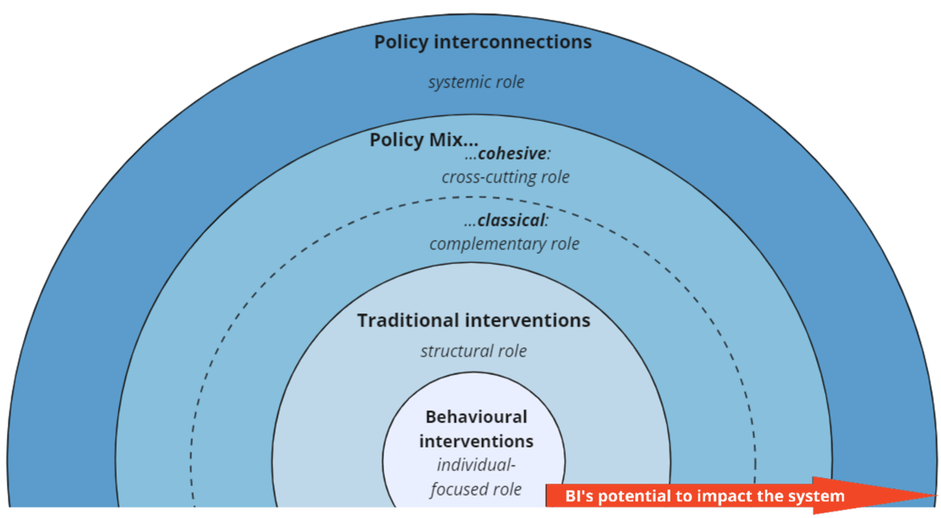
Source: JRC elaboration inspired from [39].

- Behavioural interventions: behavioural insights play an individual-focused role, directly targeting specific behaviours through tailored interventions such as nudges or boosts to encourage desired actions or decisions.
Behavioural interventions are often used as a plug-in to the policy process once the policy options have already been decided upon. One way to use behavioural interventions is as a follow-up to already existing rules set in e.g. regulations (e.g. Directive on Energy Labelling, Eco-design Regulation for Smartphones). This is for example the case when a label is mandated in a regulation, and behavioural scientists are called in to design ex post the label, making sure it is effective. Another way to use behavioural interventions is to support the communication of traditional interventions that may be already in place, with the objective of making them more transparent and acceptable (e.g. Eurobarometer Survey “Fairness Perceptions of the Green Transition”, Perceptions of distributional impacts of Fit for 55 Package [41]).
Behavioural interventions are usually low cost and easy to implement. While it is possible that cascading effects result in system-wide impact of such interventions, the effects are most often found to be marginal [42].
- Traditional Interventions: behavioural insights serve a structural role by implementing policies that affect the broader environment or system in which individuals operate, such as regulations, taxes, and subsidies, without necessarily targeting individual behaviour directly. When a behavioural element is found relevant in a policy context, behavioural insights can recommend or inform traditional instruments or policies. In this case, it feed the design of traditional interventions to modify the fundamental aspects or mechanisms of a system or environment rather than following or fixing pre-existing policy mechanisms already in place. For example the 2011 EU Consumers Rights Directive included a number of measures informed by behavioural insights, such as banning pre-ticked boxes for additional services when shopping online, which relied on inattention and the tendency to follow the default.
Behavioural insights can also inform the design of traditional policies by providing an understanding of human behaviour relevant to the policy context and feeding regulations or other traditional policies. For example the Revision of Energy Efficiency Directive and the Energy Efficiency Financing Recommendation both benefited from an understanding of energy efficiency (investment) decision drivers and identification of additional solutions through the behavioural economic lens, while the Energy Poverty Recommendation relied on insights on consumer empowerment and energy poverty drivers through the behavioural economic lens.
- Policy Mix: behavioural insights can have two different roles: (1) a complementary role, enhancing the effectiveness of behavioural interventions within a broader policy mix without directly influencing the design of traditional interventions in the mix; or (2) a cross-cutting role, informing the development and implementation of both behavioural and traditional interventions within the mix, ensuring coherence and synergy across all policy tools to achieve the intended policy goal. For example, combinations involving nudges and monetary incentives are more effective in promoting pro-environmental behaviour than monetary interventions alone [43].
Moving along those lines in energy policy making is consideration of a long-term project to map the consumer journey in relation with energy-related equipment in order to identify each step of the consumer decision-making process, including purchase, repair, and end-of-life disposal, and develop behavioural insights to address any obstacles or information needs, providing evidence supporting future energy policies.
- Policy interconnections: behavioural insights adopt a systemic role by analysing how various policies from different policy domains interact and impact the behaviour of specific stakeholders collectively, identifying synergies and conflicts between policy signals. In such analyses, the traditional approach of first identifying behavioural aspects and then designing interventions to achieve specific goals is insufficient [44]. Instead, it is crucial to consider how interventions in one domain might impact another, necessitating a holistic view of the system's dynamics.
An example of how behavioural insights could contribute comes from the intersection between tourism and climate policies. For the EU to achieve climate neutrality by 2050 long distance transport has to decarbonise but there is also a need for a reduction in overall long-distance travelling. At the same time tourism is seen as a key sector in the EU, so there is a need to reconcile how a vibrant tourism economy can be achieved with lower travel intensity or how zero-emission transport. In such cases, applying a behavioural lens allows for an assessment of potential conflicting goals across policy domains and helps promote coherence across different policy areas.
Focusing exclusively on devising behavioural interventions, is considered to have the lowest potential (or highest uncertainty) for system impact. The case where behavioural insights informs various policies simultaneously and potentially across different domains, represents the highest potential for them to impact the system.
Behavioural insights, while not revolutionising policymaking, fully embraces the principle of evidence-based policymaking by making the case that – whenever we find a behavioural element that may help determine the potential success of a given policy intervention – we ought to collect and take stock of behavioural evidence. For example, although it may make sense on paper, a new label is not necessarily the solution, unless consumers can access it, trust it, understand it, and use it to make decisions. In this sense, behavioural insights asks further questions that can help generate a clearer reply, a more effective policy response to unlock the positive potential of human decisions to tackle collective challenges.

    - Participation and citizen engagement
Citizen participation can directly impacts the implementation success of the green and digital transition in EU.

Three systemic gaps affect implementation effectiveness. First, limited awareness of participation mechanisms reduces citizen engagement with environmental initiatives. Second, fragmented performance across participation tools affects their collective impact on policy development. Third, resource allocation for participation initiatives often falls short of stated ambitions, limiting their practical effectiveness [45].
Current participation mechanisms show varying success levels. The European Citizens' Initiative has demonstrated concrete impact, with initiatives like "End the Cage Age" influencing policy development [46]. However, public consultations and Citizens' dialogues, while valuable, often struggle to reach beyond already engaged stakeholders [47]. This limited reach affects the breadth and effectiveness of public input into environmental policy development.
Evidence from recent initiatives points to three priority areas for strengthening citizen participation in green transition implementation:
- Enhancing mechanism effectiveness: stronger links between participation outcomes and policy decisions would improve engagement quality.
- Broadening engagement reach: Targeted approaches for underrepresented groups, particularly in environmental justice and energy transition discussions, would strengthen policy outcomes. The Fair Energy Transition methodology provides a tested framework for engaging diverse communities [48] .
- Strengthening implementation support: Enhanced resource allocation and clearer coordination between participation mechanisms would improve their collective impact.
The success of green transition implementation depends significantly on effective citizen engagement. While basic frameworks exist, focused enhancement of participation mechanisms would accelerate progress toward environmental objectives. Strategic investment in participation tools, combined with clear demonstration of their policy impact, would strengthen both democratic legitimacy and implementation effectiveness.
Initiatives such as the Citizen Participation and Deliberative Democracy Festival, demonstrated a vital forum for exploring the intersections of democracy, citizen engagement, and environmental issues. By bringing together diverse stakeholders and providing numerous resources, the festival fostered meaningful participation and drove policy innovation to address the most pressing challenges of our time.
The path towards a truly participatory democracy in the EU requires a multi-faceted approach. It necessitates raising awareness among citizens about their participation rights and opportunities, enhancing the effectiveness and impact of existing instruments, and fostering a stronger political commitment to citizen engagement at all levels of governance [49], [50]. By addressing these challenges, the EU can create a more inclusive, responsive, and legitimate democratic system that reflects the diverse voices and aspirations of its citizens [45], [50].

Box. Art and science in policy making
The SciArt (Science and Art) field has expanded vastly in the recent years, developing a variety of dynamics to link science and society through art and aesthetic experiences. Using artistic exploration as a new medium to explore and transfer scientific knowledge offers new ways of connecting people with scientific and artistic inquiry. This allows addressing complex issues and global challenges such as climate change in a way that science becomes easy to understand and connect to, emotionally.
The JRC SciArt programme brings together scientists with artists and policymakers to discuss matters of concern, not only to the JRC and the European Commission but also more widely to society. The results are marked with exhibitions as a way to engage with the public, provoke conversations with citizens and create cultural products of contemporary relevance.
In some cases art has a much bigger potential to convey messages to public than science and can be more effective in changing people’s minds and capturing their souls. This is particularly important for the gigantic societal shift the green transition aspires to succeed in the next years.
According to Beatriz Rodriguez-Labajos [51]
……Artivism is a growing constituent of environmental activism, articulated around three major topics. The first one is the education of audiences through performative expressions of today’s global environmental crises, especially climate change. The second one involves ecocritical reflections of environmental controversies and conflicts towards creative emancipatory practices. The third one positions art practice as an avenue for environmental improvement across different sectors (e.g. water, mining, urban) with involvement of citizens, governments, and corporate actors.
The JRC (2024) explored the role of Science and Art for transdisciplinary education, collecting insights, experiences, and recommendations on how Culture Sectors and Industries can drive Green Transition and facing the Energy Crisis’ from civil society. Combining scientific with artistic research has the potential to enrich science with new insights of ethics and aesthetics and make it more approachable and credible to people, in particular in a period of mistrust towards the institutions and populism rise.

  - Cities and regions in the green transition
Being Local and Regional Authorities the closest governance level to citizens – and, usually, the most trusted by them [52] - sub-national authorities will be the pioneers to secure the EU green transition for a sustained competitiveness. Furthermore, the continuing urbanization as a megatrend [53] is likely to continue in the future, with cities occupying approximately only 4% of EU land today, but being home to 75% of EU citizens and responsible for over 70% of global greenhouse gas emissions and waste production. While urban centers are widely recognized as hubs of technological and broader societal innovation [54], in the face of climate crisis the governance of local transition towards more sustainable production and consumption patterns has become a task defined by both urgency and uncertainty [55], [56].
The EU Climate Law emphasized the necessity of accessible, inclusive processes to engage all governance levels and societal stakeholders in achieving climate goals. The active involvement of urban and regional areas is central to implementing 70% of climate mitigation [57] and 90% of adaptation policies [58]. Furthermore, cities alone are urged to implement 50% of EGD targets in all policy thematic areas [59] and 65% of the 169 SDG targets [60].
Key consultative bodies of the EU, such as the Committee of the Regions [58], [61] and the Economic and Social Committee [62] raised concerns about the insufficient involvement of social partners and subnational authorities in the policymaking process for the green transition. The lack of effective mechanisms for multilevel governance is seen as a significant obstacle to the EGD implementation [58]. In turn, stakeholders have indicated that the local and regional execution of the EGD has been inadequate to date [63]. An unprecedented high number of policy targets, a rapidly evolving policy framework also responding to a changing geopolitical context [64], resource and skill availability [65] are further hampering the green transition and EGD policy implementation in EU cities.

8.4.1 Structural challenges hampering transformative change
Transitions imply radical transformations of current socio-technical systems (for example, energy, housing, transport, agri-food systems) [24] which, at the urban scale, co-exist and interact [66]. These systems are often resistant to radical transformation due to entrenched structures, behaviors, and vested interests, which can create inertia and pushback against efforts to shift towards more sustainable practices [67]. Many barriers (institutional, economic, technological, cultural, and behavioral) [68] are impeding transformative change and are deeply interrelated. Due to these barriers, the EGD implementation is lacking behind in all domains and acceleration is urgently needed if we want to achieve the 2030 targets [69].
Ongoing research at the JRC, based on literature review and complemented by scientists’ and experts’ opinions [69], explored these barriers and how they are intertwined. The analysis led to the identification of structural hampering conditions, i.e. systemic, self-reinforcing mechanisms embedded within current socio-technical and institutional systems that perpetuate the status quo of urban development and hinder transformative change [70]. These conditions are characterized by their interconnectedness and influence over multiple domains, creating feedback loops that amplify effects and make them resistant to change. Thus, structural conditions can be understood as the underlying, often invisible architecture of constraints that determine the trajectory of urban socio-technical systems. They are insufficient policy implementation, challenging upgrade of consolidated built environment layout, short-termism and no perceived urgency or need to change, lack of knowledge, data sharing, and trust among stakeholders, silos in policymaking, budget, and development processes, competition among stakeholders over urban space use, limited social acceptance, and limited financial resources.
These conditions are not isolated phenomena but are deeply interconnected, forming lock-ins that reinforce systemic inertia [24]. Silos in policymaking might exacerbate implementation challenges by fragmenting efforts across departments and budgets, limiting coordination and integrated approaches necessary for effective urban transitions. Short-termism and no perceived urgency or need to change play a pivotal role in sustaining the inertia of other structural conditions. This condition is directly connected to limited social acceptance, as the absence of long-term vision often undermines efforts to build public trust and support for transformative initiatives. The resulting lack of social acceptance, in turn, might diminish stakeholder engagement, reinforcing competition over urban space use, where immediate economic interests might be prioritized over long-term environmental objectives. The interplay between lack of knowledge, data sharing, and trust among stakeholders and other structural conditions further highlights their mutual reinforcement. Poor knowledge-sharing mechanisms reduce the ability to build consensus and align efforts across diverse actors, which is essential for overcoming silos in policymaking and improving policy implementation. This lack of trust also contributes to competition among stakeholders, as fragmented efforts create inefficiencies and tensions over limited resources and conflicting priorities.
These conditions are very context-dependent and, of course, are not always necessarily valid with the same magnitude. There cannot be one-size-fit-all solutions. However, Ongoing research highlighted that promising leverage points to dismantle them exist [69], [71].
The lack of adequate technical expertise in urban departments is seen as one of the most impactful barriers, serving as a foundational impediment and influencing a wide range of issues such as insufficient policy implementation, fragmented knowledge-sharing, and limited capacity for innovation in urban sustainability. For example, without adequate expertise, urban departments might struggle to implement advanced energy-efficient technologies, decarbonization strategies, or nature-based solutions, which in turn might reinforce other barriers like limited financial resources and competition over urban space use. This highlights the cascading effects of addressing – or failing to address – technical expertise within local administrations. Limited leadership emerges as another critical barrier by perpetuating fragmented decision-making, lack of strategic vision, and insufficient prioritization of sustainability transitions. Weak leadership might exacerbate barriers such as short-termism and the underestimation of participatory governance methods, as decision-makers fail to champion innovative, inclusive, and long-term approaches. The prevailing economic efficiency and GDP-oriented paradigms similarly hold a pivotal role in shaping systemic resistance. This barrier prioritizes short-term economic gains over long-term sustainability goals, influencing a wide array of challenges such as limited social acceptance, insufficient policy implementation, and competition among stakeholders. For example, the continued emphasis on economic growth metrics might discourage investments in green infrastructure or circular economy practices, reinforcing structural inertia and undermining the transformative potential of urban green transitions (see section 7.2 on beyond GDP initiatives). Different and conflicting visions on what sustainability means represent another highly influential barrier, leading to fragmented efforts and preventing the development of cohesive strategies, feeding into barriers such as competition over urban space use and lack of trust among stakeholders, in turn challenging policy coherence at all governance levels.
To further explore how these structural conditions act in local contexts, the JRC launched an open consultation which collected the view from 170 local level policymakers, coming from 105 LRAs which represent 20% of EU populations from all Member States (with the exception of Cyprus and Malta) and the most important EU urban networks (URBACT, ICLEI, EUROCITIES). Limited financial resources was ranked first, followed by short-termism and no perceived urgency to change, difficulty to upgrade consolidated built environment; lack of knowledge, data sharing, and trust among stakeholders.
Many differences emerged among Member States and policy domains. Responses from Eastern Europe (EE) policymakers confirmed the lack of adequate financial resources as the most challenging issue in all the areas but biodiversity, where competition among stakeholders over land use seems to be the most challenging question. According to North-Western (NW) countries’ respondents, inadequate funding affects specifically climate ambition, energy), and mobility areas, while lack of knowledge sharing and trust among stakeholders is the most challenging issue for circular economy, short-term mentality hampers specifically biodiversity and zero pollution ambition. The same applies for Southern Europe (SE) countries, even if they also consider inadequate financial resources as the most challenging issue for biodiversity as well (Fig. XX). There is a good recognition that political will for policy implementation has a strong influence on succeeding the green transition, especially for energy and mobility.
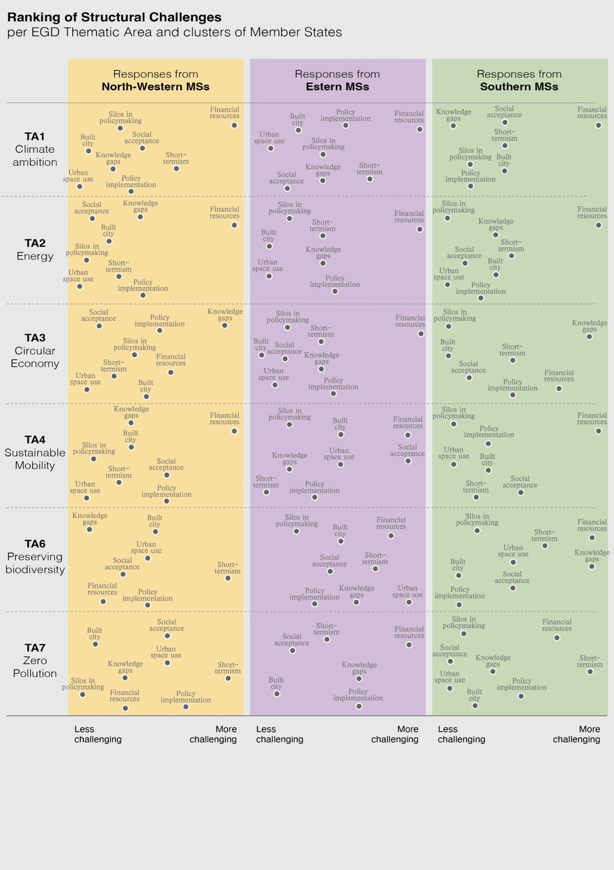
Source: Authors' elaboration.

Box XX. The local policymakers’ consultation on the EGD: target priorities and challenges
Beyond considerations on structural hampering conditions, JRC launched a consultation with local policymakers on “The future of the Green Deal (with)in cities. Priorities for and barriers to Urban Green Transitions”. The aim was to understand the policy priorities in the EGD implementation at sub-national level. The first step consisted in isolating the EGD targets involving cities in the implementation [59]. As second step, this subset of targets were submitted to academia experts to identify the most promising targets in driving the green transition at EU urban level.
All in all, respondents clearly prioritized the targets on zero pollution as the more urgent to implement in their local context (8.3/10 average score), followed by the targets for biodiversity preservation (8.1/10), climate ambition and circular economy (8.0/10), sustainable and smart mobility (7.4/10) and as last the targets on clean energy (7.2/10). When looking at clusters of member states, some differences emerged (Fig. XX), with respondents from North-West MSs which tended to prioritize the climate targets while East and South Europe MSs considering the zero pollution targets as the most urgent to implement. Respondents from East Europe perceived the mobility targets as the least urgent, with specific reference to fleet electrification- and hydrogen-related targets, while respondents from North-West and South ranked the energy targets as the latest.
Looking at more granular insights, the top three ranked targets belong to the zero pollution area and regard improving water quality by 2030, reducing microplastics of 30%, reducing waste/plastic litter at sea of 50%, and improving air quality to reduce of 55% the number of premature deaths caused by air pollution. Those are closely followed by reduce of -55% GHG emissions by 2030 (TA1), plant 3 billion trees by 2030 (TA6), eliminate the use of pesticides in sensitive areas such as urban areas (TA7), recycling or preparing for reuse 70% of packaging waste by 2030 (TA3), reverse the decline of pollinators (TA6), zero emission in urban logistics and cut the emission of transport sector of 90% by 2050 (TA4). Respondents from East Europe MSs specifically ranked the air quality target first, North-West respondents ranked the GHG emission target first, South respondents ranked the microplastic target first.
Fig. x – Scores in the urgency of implementation for the EGD targets, by thematic area and cluster of Member State (highest score means highest priority)
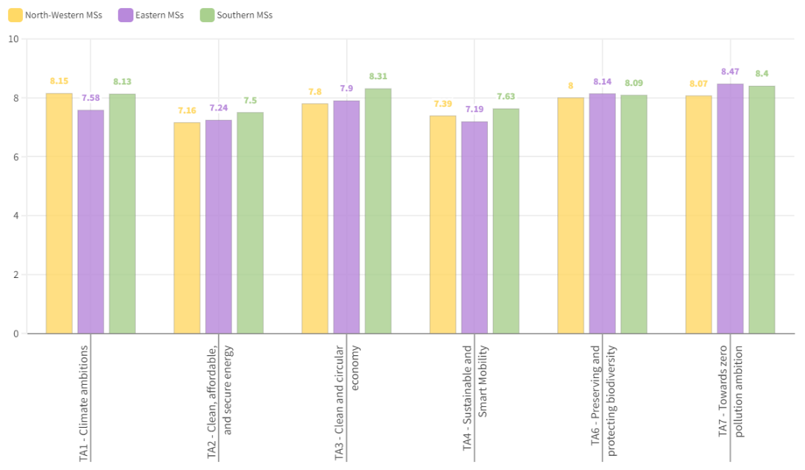
Source: [59].

8.4.1 Succeeding urban green transitions: enabling conditions
Funding is a necessary – but not sufficient alone – condition to succeed the green transition [73], with capacity building and budget management needed to make good use of existing financing tools (e.g., Cohesion Funds) and remove market barriers which hamper the labour market and business environment at national scale. To further highlight enablers against structural hampering conditions and specific policy domains at urban level, an international expert workshop was organized in October 2024. Experts from academia and science, major urban networks, climate activists and NGOs, LRAs, the CoR (ENVE Commission), and urban/landscape international firms worked in thematic tables to collectively identify enabling conditions for the green transition and imagine the city of tomorrow in response to the desirable climate neutrality 2050 scenario. Several advanced techniques, including a novel serious game designed to identify enablers for implementing the EGD locally and foresight exercises, were employed to co-create urban transition scenarios (Box XX).
Overall, the working groups identified more than 100 enablers to achieve the EGD policy ambitions and overcome the structural hampering conditions. Recurrent topics emerged as key enabling conditions to foster the green transition at urban level: community and citizen engagement, upgrade of urban infrastructure and NBS uptake, innovative governance and policymaking, streamlined communication and information sharing, proper education and skills, adequate financial resources and public-private cooperation, coupled energy and digital transitions (Figure XX).
Proposed granular enablers might be supportive of several policies involving EU cities for implementation. Figure XX links the list of enablers to the main EGD policies. The transversal enablers identified during the workshop, mostly belonging to comprehensive, systemic planning and strengthened citizen and community engagement, might serve as essential building blocks for achieving urban policy public adoption and implementation. Actions such as engaging local content creators, leveraging digital tools like digital twins, and organizing public meetings allow urban governments to demystify complex policy objectives, making them accessible to citizens and stakeholders. Furthermore, interdisciplinary skill-building and systemic partnerships with academia and research bodies might ensure that urban policies remain informed by cutting-edge research and reflect diverse societal perspectives. Critically, adequate financial resources and public-private partnerships are needed in all areas.
In the context of climate ambitions (TA1), urban enablers such as “3-30-300 based policies”, the promotion of wildlife corridors, and the establishment of minimum greenery thresholds contribute to the broader goals of emissions reduction and land-use optimization. These enablers might support TA1 policies (e.g., the ETS) and directly contribute to TA6-TA7 ambitions as well. Particularly impactful might also be initiatives like converting roads to cycling lanes and clustering urban functions through revised zoning plans, finally implementing the “15-minute city” concept. These actions might reduce urban sprawl, enhance carbon sequestration, and promote sustainable mobility. Intermodal hubs, e-mobility incentives, and the development of public transport infrastructure, are considered pivotal for achieving the Sustainable and Smart Mobility Strategy and AFIR targets, often linked to air pollution and GHG emissions. These enablers have been thought to be key in reducing urban reliance on private vehicles while promoting cleaner, multimodal transport options and people’s health. Strong is put in social acceptance as well, which is also seen as one of the most hampering challenges in this area. The zero-pollution ambitions might benefit from higher data quality and granularity via monitoring systems spread in the urban built environment. Promoting NBS adoption and implementing green standards directly into building design might contribute to Zero Pollution Action Plan, the Ambient Air Quality Directive and some energy policies’ requirements. The urgent push for an energy transition is underscored by both technological and behavioral enablers. Massive incentives for the electrification of public transport, intermodal hubs, e-mobility infrastructure and integration, and upgrading building stock performance are priority transformative initiatives aligned with policies like the Energy Efficiency Directive and the Energy Performance of Buildings Directive while contributing to sustainable and smart mobility. Complementing these actions are the enablers focused on proper education and skills, such as reskilling programs for green jobs and site-specific public awareness campaigns about energy-saving behaviors. In the circular economy domain, enablers like shorter food supply chains and the development of car-free zones to support local markets reflect the centrality of community engagement in reducing food waste. The establishment of food councils and incentives for innovative business models further highlights the role of innovative governance in driving circularity. Finally, enablers like promoting endemic species, banning monocultures, and introducing greening standards ensure that cities contribute to the conservation of natural habitats and achieving the quality standards required by new indicators of the NRL. Public awareness campaigns and local initiatives, such as food councils, might complement these efforts by fostering community-level engagement in biodiversity conservation and nutritious local food accessibility.
While some challenges, especially referring to the limited financial resources, are acknowledged with high degree of consensus, others are highly policy domain- and context-dependent, further reinforcing the argument against a one-size-fits-all approach for the green transition. The results advocate for EU-level policies that prioritize flexibility and support local adaptation of EU ambitions. A clear need for tailoring solutions to boost policy implementation and address the unique challenges and priorities of different regions [76] and cities emerged. Conversely, LRAs must ensure ambition alignment and policy coherence for sustainable development while delivering site-specific priorities and citizens’ needs, finally securing the policy implementation and monitoring process.

Figure XX Synthesis and rating of enablers raised to face structural conditions hampering the green transition in EU cities, clustered per enabling condition
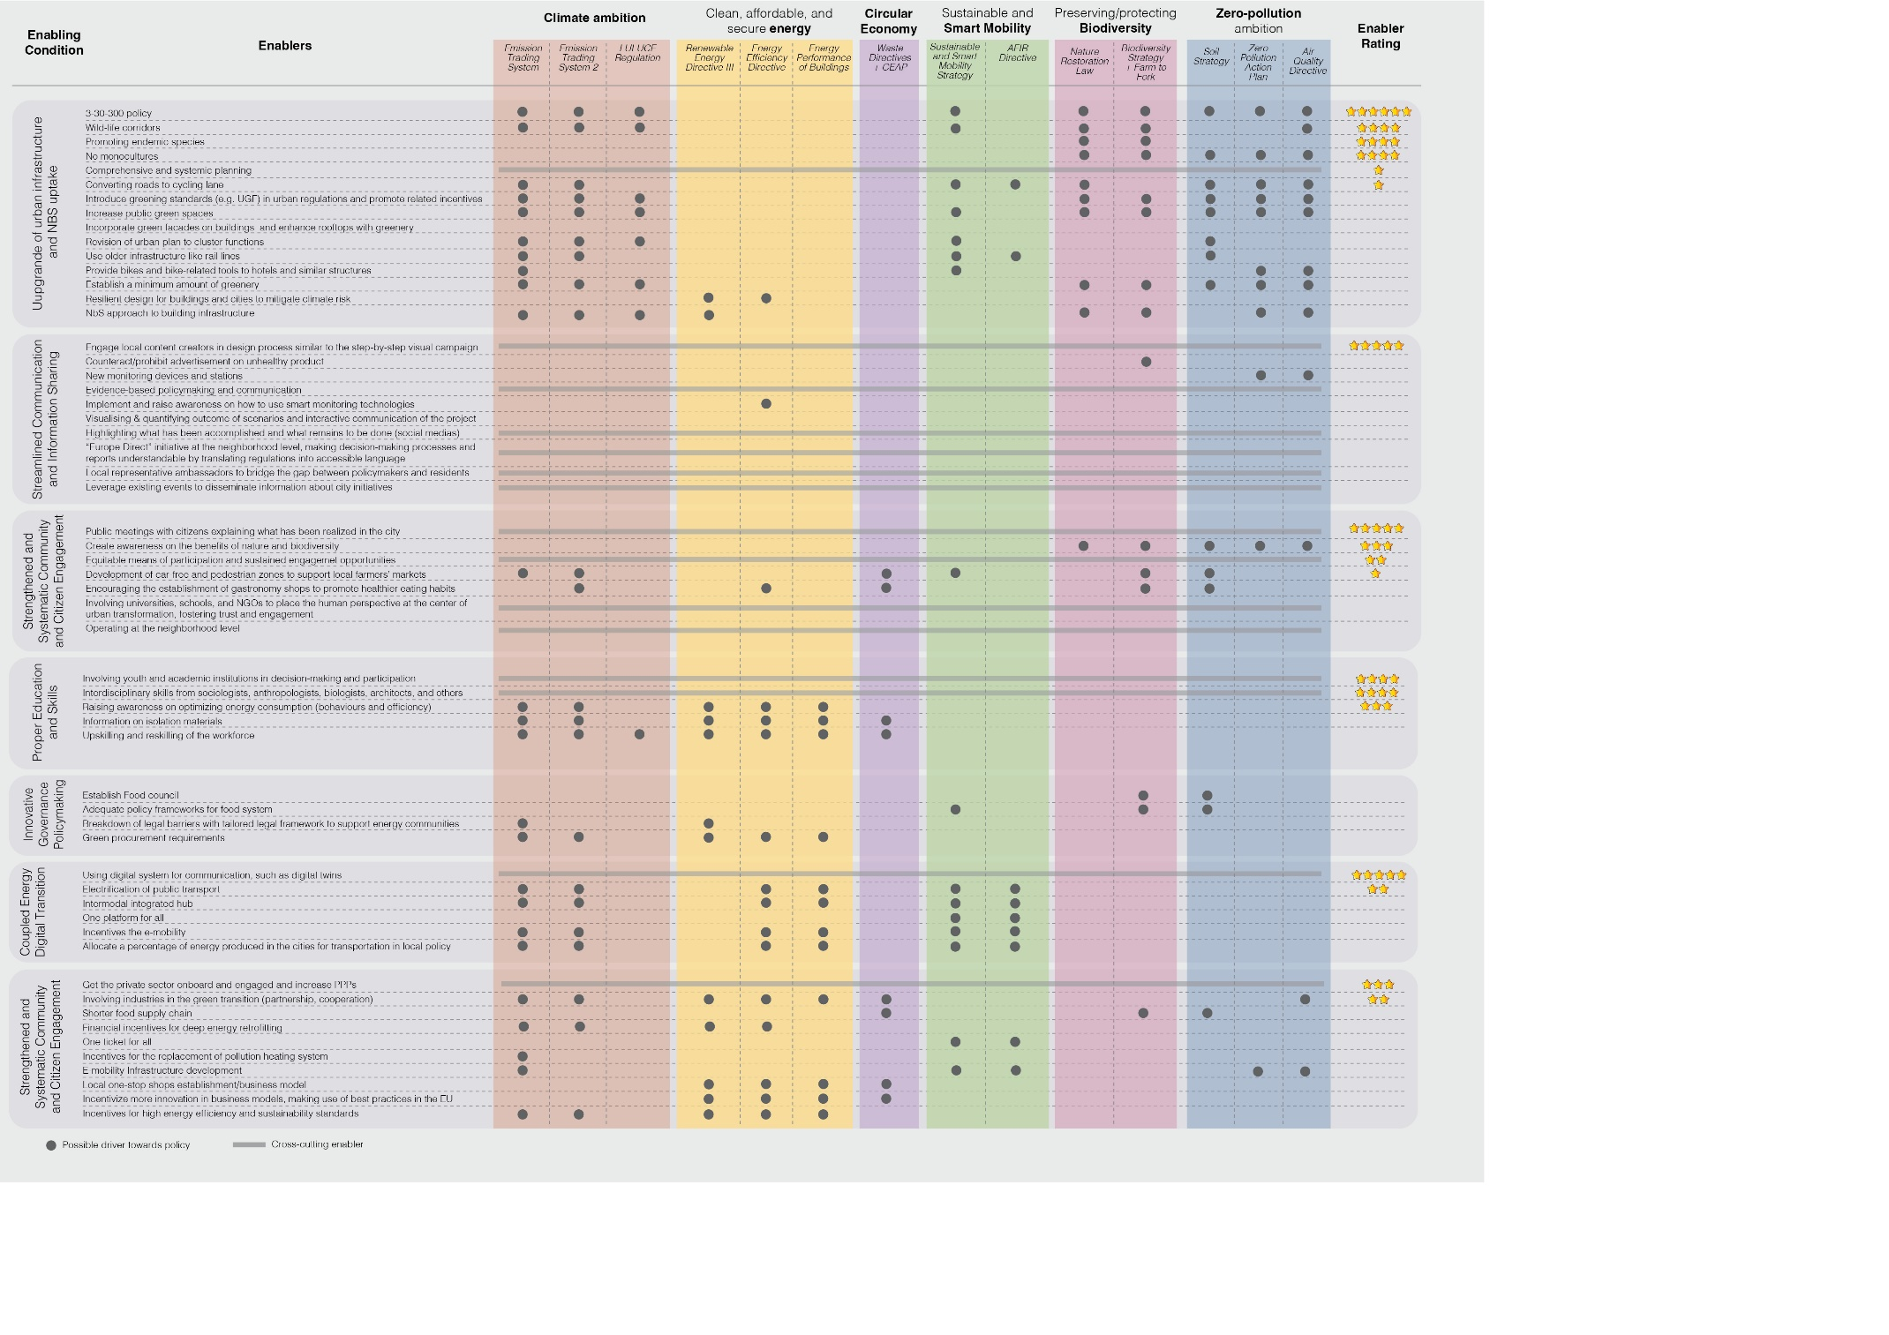Source: Authors' elaboration.

Box XX. The shapEUrbe board game: SHAPing the green transition in EU URBan Environment under the 2030 Agenda and European Green Deal
During the workshop a novel serious game designed at the JRC, shapEUrbe, was employed to engage participants in tackling structural challenges and identifying enablers to advance the EGD targets within EU urban environments. The game fosters collaboration, creativity, and critical thinking, simulating the complexities of urban green transitions toward achieving climate neutrality by 2050 in four major steps: Setting the scene, the Road to 2030, Rating enablers, Exploring gaps and ambitions (Fig. XX).
During their turn, the playing team participants must identify at least one enabler or good practice in support of a target to advance their pawn. Teams collaboratively discuss the relevance and application of enablers, writing keywords on the cards to document their ideas. Opponent teams can intervene by playing one barrier card per turn, forcing the active team to address the obstacle before proceeding. Both teams must collaborate to co-identify enablers that resolve the structural hampering conditions, ensuring progress for all participants. Once resolved, the turn passes to the opponent team. The gameplay continues for 50–60 minutes or until one team reaches 2030. The game was designed with a structured and rigorous approach to avoid open-ended and unrestrained discussions, often disconnected from real-world constraints in such approaches. Instead, it grounded participants in a scenario resembling interrelated challenges of urban transitions. The inclusion of barriers and references to hampering conditions, to be collectively addressed, creates competitive dynamics between teams, requiring them to navigate obstacles built into the game. At the same time, the use of targets ensures discussions remained focused on tangible outcomes to favor policy objective implementations. Being highly replicable at different scales, discussions are ongoing to test the game in real-world environments leveraging ongoing collaborations with urban networks.
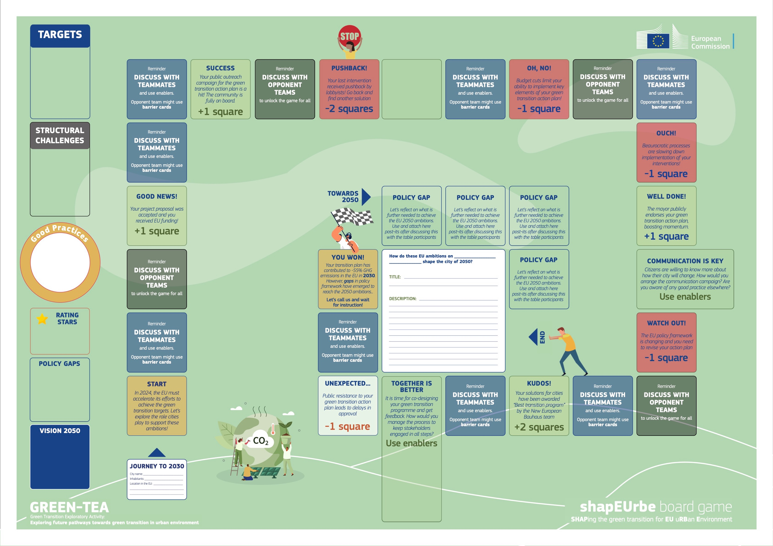
Figure XX. ShapEUrbe board game. Designed by M. Trane.

References

[1] EUROPEAN COMMISSION, ‘Clean Industrial Deal - European Commission’. Accessed: Mar. 04, 2025. [Online]. Available: https://commission.europa.eu/topics/eu-competitiveness/clean-industrial-deal_en
[2] EUROPEAN COMMISSION, COMMUNICATION FROM THE COMMISSION TO THE EUROPEAN PARLIAMENT, THE EUROPEAN COUNCIL, THE COUNCIL, THE EUROPEAN ECONOMIC AND SOCIAL COMMITTEE AND THE COMMITTEE OF THE REGIONS A Competitiveness Compass for the EU. 2025. Accessed: Mar. 04, 2025. [Online]. Available: https://eur-lex.europa.eu/legal-content/EN/TXT/?uri=CELEX%3A52025DC0030
[3] European Commission. Joint Research Centre., GreenComp, the European sustainability competence framework. LU: Publications Office, 2022. Accessed: Apr. 13, 2025. [Online]. Available: https://data.europa.eu/doi/10.2760/13286
[4] European Commission. Joint Research Centre., Clean Energy Technology Observatory, Overall strategic analysis of clean energy technology in the European Union: 2024. LU: Publications Office, 2025. Accessed: Apr. 13, 2025. [Online]. Available: https://data.europa.eu/doi/10.2760/3507717
[5] Kuokkanen, A., ‘Skills for the energy transition in the changing labour market’, European Commission, Petten, vol. Science for Policy Brief, 2023.
[6] ‘The state of renewable energies in Europe. Edition 2023. 22st EurObserv’ER report’, Observ’ER, 2023. [Online]. Available: https://publica.fraunhofer.de/handle/publica/467638
[7] European Commission. Directorate General for Employment, Social Affairs and Inclusion., Employment and social developments in Europe 2023. Addressing labour shortages and skills gaps in the EU. LU: Publications Office, 2023. Accessed: Apr. 13, 2025. [Online]. Available: https://data.europa.eu/doi/10.2767/089698
[8] European Commission. Joint Research Centre., Employment in the energy sector: status report 2020. LU: Publications Office, 2020. Accessed: Apr. 13, 2025. [Online]. Available: https://data.europa.eu/doi/10.2760/95180
[9] European Commission. Directorate General for Research and Innovation., Science, research and innovation performance of the EU, 2024: a competitive Europe for a sustainable future. LU: Publications Office, 2024. Accessed: Apr. 13, 2025. [Online]. Available: https://data.europa.eu/doi/10.2777/965670
[10] European Commission. Joint Research Centre., The future of jobs is green. LU: Publications Office, 2021. Accessed: Apr. 13, 2025. [Online]. Available: https://data.europa.eu/doi/10.2760/218792
[11] European Commission. Directorate General for Energy. and ECORYS., The net-zero manufacturing industry landscape across Member States: final report. LU: Publications Office, 2025. Accessed: Apr. 14, 2025. [Online]. Available: https://data.europa.eu/doi/10.2833/2249632
[12] ‘Regulation (EU) 2024/1735 on establishing a framework of measures for strengthening Europe’s net-zero technology manufacturing ecosystem and amending Regulation (EU) 2018/1724’. Accessed: Apr. 14, 2025. [Online]. Available: https://eur-lex.europa.eu/eli/reg/2024/1735/oj/eng
[13] M. Draghi, ‘The future of European competitiveness (Part B) – In-depth analysis and recommendations’. European Commission, Sep. 2024. [Online]. Available: https://commission.europa.eu/document/download/ec1409c1-d4b4-4882-8bdd-3519f86bbb92_en?filename=The%20future%20of%20European%20competitiveness_%20In-depth%20analysis%20and%20recommendations_0.pdf
[14] COMMISSION STAFF WORKING DOCUMENT IMPACT ASSESSMENT Accompanying the document COMMUNICATION FROM THE COMMISSION TO THE EUROPEAN PARLIAMENT, THE COUNCIL, THE EUROPEAN ECONOMIC AND SOCIAL COMMITTEE AND THE COMMITTEE OF THE REGIONS Stepping up Europe’s 2030 climate ambition Investing in a climate-neutral future for the benefit of our people. 2020. Accessed: Nov. 29, 2023. [Online]. Available: https://eur-lex.europa.eu/legal-content/EN/TXT/?uri=SWD:2020:176:FIN
[15] Internationale Agentur für Erneuerbare Energien and Methanol Institute, Eds., Renewable energy and jobs: annual review 2022. in Labour and policy perspectives - special edition. Abu Dhabi: International Renewable Energy Agency, 2022.
[16] European Education and Culture Executive Agency., Learning for sustainability in Europe: building competences and supporting teachers and schools : Eurydice report. LU: Publications Office, 2024. Accessed: Apr. 14, 2025. [Online]. Available: https://data.europa.eu/doi/10.2797/81397
[17] European Commission. Joint Research Centre., The consumer footprint calculator: estimating the environmental impacts of the consumption of EU citizens and their lifestyle. LU: Publications Office, 2022. Accessed: Apr. 14, 2025. [Online]. Available: https://data.europa.eu/doi/10.2760/597000
[18] EUROPEAN COMMISSION, ‘Commission Recommendation of 16.12.2021 on the Environmental Footprint methods to measure and communicate the life cycle environmental performance of products and organisations. C(2021) 9332 final.’ 2021. [Online]. Available: https://eur-lex.europa.eu/resource.html?uri=cellar:75e0de0f-5e6d-11ec-9c6c-01aa75ed71a1.0019.02/DOC_1&format=PDF
[19] J. Cortina-Segarra et al., ‘Barriers to ecological restoration in Europe: expert perspectives’, Restoration Ecology, vol. 29, no. 4, p. e13346, 2021, doi: 10.1111/rec.13346.
[20] C. Matti, K. Jensen, L. Bontoux, P. Goran, A. Pistocchi, and M. Salvi, Towards a fair and sustainable Europe 2050: social and economic choices in sustainability transitions. LU: Publications Office of the European Union, 2023. Accessed: Nov. 29, 2023. [Online]. Available: https://data.europa.eu/doi/10.2760/804844
[21] M. Janssen, I. Wanzenböck, L. Fünfschilling, and D. Pontikakis, ‘Capacities for transformative innovation in public administrations and governance systems: Evidence from pioneering policy practice’, Publications Office of the European Union, Luxembourg, Science for Policy Report, 2023. doi: 10.2760/220273.
[22] L. Marelli et al., ‘Delivering the EU Green Deal - Progress towards targets’, European Commission: Joint Research Centre, Luxembourg, JRC140372, Jan. 2025. doi: 10.2760/3105205.
[23] G. Bianchi et al., Eds., Innovation for place-based transformations: ACTIONbook, practices and tools. Luxembourg: Publications Office, 2024. doi: 10.2760/234679.
[24] F. W. Geels, ‘Socio-technical transitions to sustainability: a review of criticisms and elaborations of the Multi-Level Perspective’, Current Opinion in Environmental Sustainability, vol. 39, pp. 187–201, Aug. 2019, doi: 10.1016/j.cosust.2019.06.009.
[25] P. Braunerhjelm, M. Andersson, K. Blind, and J. E. Eklund, Eds., Handbook of Innovation and Regulation. Edward Elgar Publishing, 2023. doi: 10.4337/9781800884472.
[26] M. Draghi, ‘The future of European competitiveness’, EU, Sep. 2024. [Online]. Available: https://commission.europa.eu/document/download/ec1409c1-d4b4-4882-8bdd-3519f86bbb92_en?filename=The%20future%20of%20European%20competitiveness_%20In-depth%20analysis%20and%20recommendations_0.pdf
[27] European Commission. Joint Research Centre. and European Institute of Innovation and Technology Climate KIC, Co-creation for policy :participatory methodologies to structure multi stakeholder policymaking processes. LU: Publications Office, 2022. Accessed: Apr. 14, 2025. [Online]. Available: https://data.europa.eu/doi/10.2760/495731
[28] European Environment Agency., Knowledge for action: empowering the transition to a sustainable Europe. LU: Publications Office, 2021. Accessed: Aug. 27, 2024. [Online]. Available: https://data.europa.eu/doi/10.2800/713905
[29] REPORT FROM THE COMMISSION TO THE EUROPEAN PARLIAMENT AND THE COUNCIL on the Review of the Regulation on the Governance of the Energy Union and Climate Action. 2024. Accessed: Apr. 14, 2025. [Online]. Available: https://eur-lex.europa.eu/legal-content/EN/TXT/?uri=CELEX:52024DC0550
[30] COMMISSION STAFF WORKING DOCUMENT EVALUATION Accompanying the document REPORT FROM THE COMMISSION TO THE EUROPEAN PARLIAMENT AND THE COUNCIL on the Review of the Regulation on the Governance of the Energy Union and Climate Action. 2024. Accessed: Apr. 14, 2025. [Online]. Available: https://eur-lex.europa.eu/legal-content/EN/TXT/?uri=CELEX%3A52024SC0200
[31] J. S. Simmonds et al., ‘Retaining natural vegetation to safeguard biodiversity and humanity’, Conservation Biology, vol. 37, no. 3, p. e14040, 2023, doi: 10.1111/cobi.14040.
[32] W. H. Van Der Putten, R. D. Bardgett, M. Farfan, L. Montanarella, J. Six, and D. H. Wall, ‘Soil biodiversity needs policy without borders’, Science, vol. 379, no. 6627, pp. 32–34, Jan. 2023, doi: 10.1126/science.abn7248.
[33] A. Marques et al., ‘A research perspective towards a more complete biodiversity footprint: a report from the World Biodiversity Forum’, Int J Life Cycle Assess, vol. 26, no. 2, pp. 238–243, Feb. 2021, doi: 10.1007/s11367-020-01846-1.
[34] S. Rivas, R. Urraca, P. Bertoldi, and C. Thiel, ‘Towards the EU Green Deal: Local key factors to achieve ambitious 2030 climate targets’, Journal of Cleaner Production, vol. 320, p. 128878, Oct. 2021, doi: 10.1016/j.jclepro.2021.128878.
[35] J. A. Ordonez, T. Vandyck, K. Keramidas, R. Garaffa, and M. Weitzel, ‘Just Energy Transition Partnerships and the future of coal’, Nat. Clim. Chang., vol. 14, no. 10, pp. 1026–1029, Oct. 2024, doi: 10.1038/s41558-024-02086-z.
[36] T. Piketty, ‘Capital and ideology: A global perspective on inequality regimes’, British Journal of Sociology, vol. 72, no. 1, pp. 139–150, Jan. 2021, doi: 10.1111/1468-4446.12836.
[37] J. Velázquez et al., ‘Planning Restoration of Connectivity and Design of Corridors for Biodiversity Conservation’, Forests, vol. 13, no. 12, Art. no. 12, Dec. 2022, doi: 10.3390/f13122132.
[38] J. Barreiro-Hurle et al., ‘Willing or complying? The delicate interplay between voluntary and mandatory interventions to promote farmers’ environmental behavior’, Food Policy, vol. 120, p. 102481, 2023, doi: https://doi.org/10.1016/j.foodpol.2023.102481.
[39] European Commission. Joint Research Centre., Unlocking the full potential of behavioural insights for policy: from influencing the individual to shaping the system. LU: Publications Office, 2025. Accessed: Apr. 14, 2025. [Online]. Available: https://data.europa.eu/doi/10.2760/7367599
[40] European Commission, Better regulation toolbox. 2023. [Online]. Available: https://commission.europa.eu/law/law-making-process/better-regulation/better-regulation-guidelines-and-toolbox/better-regulation-toolbox_en?prefLang=it
[41] T. Vandyck, N. Della Valle, U. Temursho, and M. Weitzel, ‘EU climate action through an energy poverty lens’, Sci Rep, vol. 13, no. 1, Art. no. 1, Apr. 2023, doi: 10.1038/s41598-023-32705-2.
[42] M. Vlasceanu et al., ‘Addressing climate change with behavioral science: A global intervention tournament in 63 countries’, Sci. Adv., vol. 10, no. 6, p. eadj5778, Feb. 2024, doi: 10.1126/sciadv.adj5778.
[43] M. Alt, H. Bruns, N. DellaValle, and I. Murauskaite-Bull, ‘Synergies of interventions to promote pro-environmental behaviors – A meta-analysis of experimental studies’, Global Environmental Change, vol. 84, p. 102776, Jan. 2024, doi: 10.1016/j.gloenvcha.2023.102776.
[44] Del Valle, Emiliano Diaz, Jang, Chaning, and Wendel, Steve, ‘Behavioral systems: Combining behavioral science and systems analysis’, Busara Groundwork, Research Agenda, no. 8, Jan. 2024.
[45] Geissel, Brigitte, ‘Introduction: On the evaluation of participatory innovations – a preliminary framework’, Brigitte Geissel and Marko Jonas., vol. Participatory Democratic Innovations in Europe: Improving the Quality of Democracy?, Leverkusen: Verlag Barbara Budrich, 2013, pp. 8–32. [Online]. Available: https://doi.org/10.2307/j.ctvdf0gdc.4
[46] D. Hierlemann, S. Roch, P. Butcher, J. A. Emmanouilidis, C. Stratulat, and M. de Groot, Under construction: citizen participation in the European Union. Gütersloh: Verlag Bertelsmann Stiftung, 2022.
[47] COMMUNICATION FROM THE COMMISSION TO THE EUROPEAN PARLIAMENT, THE COUNCIL, THE EUROPEAN ECONOMIC AND SOCIAL COMMITTEE AND THE COMMITTEE OF THE REGIONS On the European democracy action plan. 2020. Accessed: Apr. 16, 2025. [Online]. Available: https://eur-lex.europa.eu/legal-content/EN/TXT/?uri=COM%3A2020%3A790%3AFIN&qid=1607079662423
[48] Rübel J., Steinberg R., Make the invisible visible – How to engage with hard-to-reach citizens for policy development? Methodology, learnings, and best practices from the project “Fair Energy Transition for All”, King Baudouin Foundation. 2023.
[49] C. Pateman, ‘Participatory Democracy Revisited’, Perspect. polit., vol. 10, no. 1, pp. 7–19, Mar. 2012, doi: 10.1017/S1537592711004877.
[50] OECD, Innovative Citizen Participation and New Democratic Institutions: Catching the Deliberative Wave. OECD, 2020. doi: 10.1787/339306da-en.
[51] B. Rodriguez-Labajos, ‘Artistic activism promotes three major forms of sustainability transformation’, Current Opinion in Environmental Sustainability, vol. 57, p. 101199, Aug. 2022, doi: 10.1016/j.cosust.2022.101199.
[52] European Committee of the Regions . Commission for Citizenship, Governance, Institutional and External Affairs., Reflecting on Europe: how Europe is perceived by people in regions and cities ? LU: Publications Office, 2018. Accessed: Apr. 16, 2025. [Online]. Available: https://data.europa.eu/doi/10.2863/820345
[53] European Commission. Secretariat General., 2023 strategic foresight report: sustainability and people’s wellbeing at the heart of Europe’s open strategic autonomy. LU: Publications Office, 2023. Accessed: Apr. 03, 2025. [Online]. Available: https://data.europa.eu/doi/10.2792/889778
[54] C. Genta, E. Sanyé-Mengual, S. Sala, and P. Lombardi, ‘The Consumption Footprint as possible indicator for environmental impact evaluation at city level. The case study of Turin (Italy)’, Sustainable Cities and Society, vol. 79, p. 103679, Apr. 2022, doi: 10.1016/j.scs.2022.103679.
[55] N. Frantzeskaki, ‘Bringing Transition Management to Cities: Building Skills for Transformative Urban Governance’, Sustainability, vol. 14, no. 2, p. 650, Jan. 2022, doi: 10.3390/su14020650.
[56] D. A. Loorbach, ‘Designing radical transitions: a plea for a new governance culture to empower deep transformative change’, City Territ Archit, vol. 9, no. 1, p. 30, Oct. 2022, doi: 10.1186/s40410-022-00176-z.
[57] Local Alliance, ‘Joint Letter to EU leaders’, 2024. [Online]. Available: https://iclei-europe.org/fileadmin/user_upload/Pdfs/2024/Final_Local_Alliance_Letter_to_EU_Leaders.pdf
[58] European Committee of the Regions ., The state of regions and cities: EU annual report 2024. LU: Publications Office, 2024. Accessed: Apr. 16, 2025. [Online]. Available: https://data.europa.eu/doi/10.2863/802688
[59] M. Trane, S. Borchardt, L. Marelli, A. Siragusa, R. Pollo, and P. Lombardi, ‘What Role for Cities in the Green Deal? Analysis of Policy Framework, Interlinkages and Contribution to the 2030 Agenda’, Sustainable Development, p. sd.3423, Mar. 2025, doi: 10.1002/sd.3423.
[60] OECD, A Territorial Approach to the Sustainable Development Goals: Synthesis report. in OECD Urban Policy Reviews. OECD, 2020. doi: 10.1787/e86fa715-en.
[61] European Committee of the Regions, ‘The future of the Green Deal: taking stock and looking ahead’, Dec. 2023. Accessed: Jan. 10, 2024. [Online]. Available: https://cor.europa.eu/en/engage/Documents/RegHub/green-deal-taking-stock-looking-ahead.pdf
[62] Opinion of the European Economic and Social Committee on ‘European Climate Pact’ (Exploratory opinion). 2020. Accessed: Apr. 16, 2025. [Online]. Available: https://eur-lex.europa.eu/legal-content/EN/TXT/?uri=CELEX%3A52020AE1432
[63] EC, COMMISSION STAFF WORKING DOCUMENT IMPACT ASSESSMENT REPORT Part 1 Accompanying the document COMMUNICATION FROM THE COMMISSION TO THE EUROPEAN PARLIAMENT, THE COUNCIL, THE EUROPEAN ECONOMIC AND SOCIAL COMMITTEE AND THE COMMITTEE OF THE REGIONS Securing our future Europe’s 2040 climate target and path to climate neutrality by 2050 building a sustainable, just and prosperous society. 2024. Accessed: May 28, 2024. [Online]. Available: https://eur-lex.europa.eu/legal-content/EN/TXT/?uri=CELEX%3A52024SC0063
[64] C. Matti, K. Jensen, L. Bontoux, P. Goran, A. Pistocchi, and M. Salvi, ‘Towards a fair and sustainable Europe 2050: Social and economic choices in sustainability transitions’, JRC Publications Repository. Accessed: May 28, 2024. [Online]. Available: https://publications.jrc.ec.europa.eu/repository/handle/JRC133716
[65] G. Ulpiani and N. Vetters, ‘On the risks associated with transitioning to climate neutrality in Europe: A city perspective’, Renewable and Sustainable Energy Reviews, vol. 183, p. 113448, Sep. 2023, doi: 10.1016/j.rser.2023.113448.
[66] B. Breitschopf, A. Grimm, A. Billerbeck, S. Wydra, and J. Köhler, ‘Towards understanding interactions between socio-technical systems in sustainability transitions’, Energy Research & Social Science, vol. 106, p. 103323, Dec. 2023, doi: 10.1016/j.erss.2023.103323.
[67] L. Temper, M. Walter, I. Rodriguez, A. Kothari, and E. Turhan, ‘A perspective on radical transformations to sustainability: resistances, movements and alternatives’, Sustain Sci, vol. 13, no. 3, pp. 747–764, May 2018, doi: 10.1007/s11625-018-0543-8.
[68] E. Croci, B. Lucchitta, and T. Molteni, ‘Low carbon urban strategies: An investigation of 124 European cities’, Urban Climate, vol. 40, p. 101022, Dec. 2021, doi: 10.1016/j.uclim.2021.101022.
[69] Trane, M., Marelli, L., Pollo, R., and Lombardi, P., ‘On eight structural conditions hampering urban green transitions in EU cities’, Urban Science, forthcoming 2025.
[70] H. Dorst, A. Van Der Jagt, H. Runhaar, and R. Raven, ‘Structural conditions for the wider uptake of urban nature-based solutions – A conceptual framework’, Cities, vol. 116, p. 103283, Sep. 2021, doi: 10.1016/j.cities.2021.103283.
[71] Trane, M., ‘SHAPEURBE – SHAPing the green transition in EU URBan Environments under the “2030 Agenda” and the “EU Green Deal”’, Doctoral Thesis, Politecnico di Torino. Collaborative Doctoral Partnership with the Joint Research Centre.
[72] European Commission, ‘The EU regional Social Progress Index 2.0. 2024 edition’, 2024. [Online]. Available: https://ec.europa.eu/regional_policy/sources/work/spi_2024/EUSPI_2024_working%20paper.pdf
[73] European Commission, ‘Ninth Report on economic, social and territorial cohesion’, 2024.
[74] C. C. Konijnendijk, ‘Evidence-based guidelines for greener, healthier, more resilient neighbourhoods: Introducing the 3–30–300 rule’, J. For. Res., vol. 34, no. 3, pp. 821–830, Jun. 2023, doi: 10.1007/s11676-022-01523-z.
[75] C. Moreno, Z. Allam, D. Chabaud, C. Gall, and F. Pratlong, ‘Introducing the “15-Minute City”: Sustainability, Resilience and Place Identity in Future Post-Pandemic Cities’, Smart Cities, vol. 4, no. 1, pp. 93–111, Jan. 2021, doi: 10.3390/smartcities4010006.
[76] A. Buzási et al., ‘European patterns of local adaptation planning—a regional analysis’, Reg Environ Change, vol. 24, no. 2, p. 59, Apr. 2024, doi: 10.1007/s10113-024-02211-w.

The GreenComp is the European competence framework for sustainability, offering common reference points for developing and assessing knowledge, skills, and attitudes on climate change and sustainable development [3].
Eurostat, Environmental goods and services sector accounts [env_ac_egss1]. Clean energy sector contains CEPA1, CREMA13A and CREMA13B. See the Methodological note in Box 4 of [4]
DG ECFIN Business and consumer survey database, subsector data for 2024.
This evidence has been developed under AMEDI (Assessing and Monitoring Employment and Distributional Impacts of the Green Deal), a joint cooperation between the Directorate-General for Employment, Social Affairs and Inclusion (DG EMPL) and the Joint Research Centre (JRC) of the European Commission.
The 16 environmental impact categories of the Environmental Footprint method (the recommended method by the European Commission for Impact assessment [18]) are: Climate change; Ozone depletion; Particulate matter; Ionising radiation; Photochemical ozone formation; Acidification; Eutrophication, terrestrial; Eutrophication, freshwater; Eutrophication marine; Water use; Land use; Resource use, fossils; Resource use, minerals and metals; Human toxicity, cancer; Human toxicity, non-cancer and Ecotoxicity, freshwater.
https://knowledge4policy.ec.europa.eu/foresight/tool/megatrends-hub_en
Clusters of Member States were organized following the grouping used in previous research by the EC, such as the 2024 Social Progress Research 2.0 [72].
Bulgaria, Czechia, Estonia, Croatia, Latvia, Lithuania, Hungary, Poland, Romania, Slovenia, Slovakia.
Belgium, Denmark, Germany, Ireland, France, Luxembourg, Netherlands, Austria, Finland, Sweden.
Greece, Spain, Italy, Cyprus, Malta, Portugal.
B Detail of experts from academia and science (TU Delft, Politecnico di Torino, Università Bocconi of Milan, University of Dundee, University of Padua, Mediterranean Centre on Climate Change – CMCC, and the JRC), major urban networks (ICLEI, URBACT, SDSN Italy, EIT Urban Mobility, and Italian Sustainable Universities network – RUS), climate activists and NGOs (Agroecology Europe and the Earth Society), LRAs (Città di Torino, Città di Milano, Toscana region), the CoR (ENVE Commission), and urban/landscape international firms (IG, LAND, Snohetta).
The rule requires that every citizen should be able to see at least three trees from their home, have 30 percent tree canopy cover in their neighbourhood and not live more than 300 m away from the nearest park or green space [74].
The 15-minute city is presented as “a new urban model that promotes a human-centric and environmentally sustainable urban future” leveraging urban environments’ potential to drive a green and just transition in EU cities. At its core, it envisions cities designed or reimagined to ensure that residents of all ages, backgrounds, and abilities can meet their daily needs (housing, work, food, healthcare, education, culture, and leisure) within a 15-minute walk or bike ride. This model emphasizes decentralization and encourages a shift away from reliance on private vehicles, simultaneously reducing fossil fuel consumption and enhancing the quality of life for citizens [75].

